LAB NO: 9

Lab-9: To implement K-Means Clustering and Hierarchical Clustering algorithms..

DATASET AND RESOURCES : wholesale dataset from classroom and Python/Jupyter Notebook

DATE OF PERFORMANCE:23 -10 -2026

GITHUB REPO LINK :
https://github.com/Prabhkirat-Singh-Marwah/ML-PRACTICALS/tree/main/Practical-09

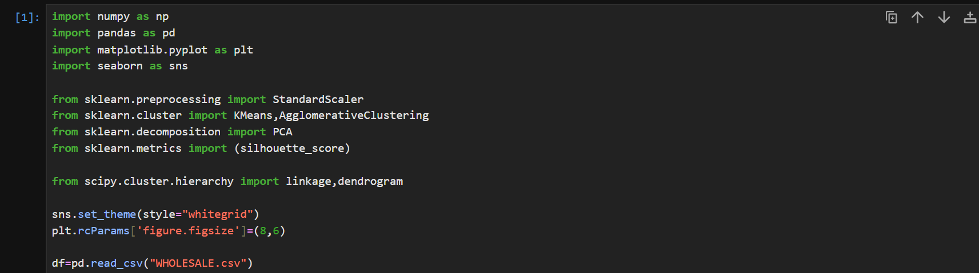this command imports all the libraries needed to clean , pre process and do all the calculation on our dataset.

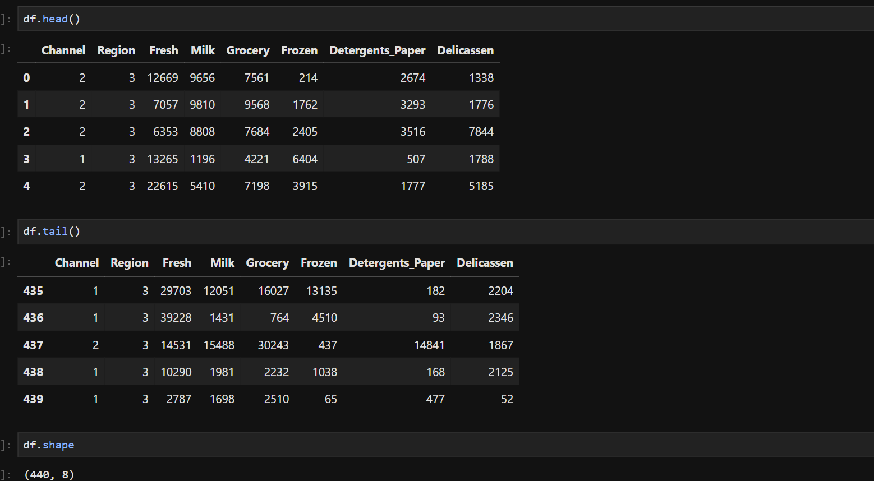
These commands print the top 5 rows, bottom 5 rows and dimension of our dataset ie, rows by column.

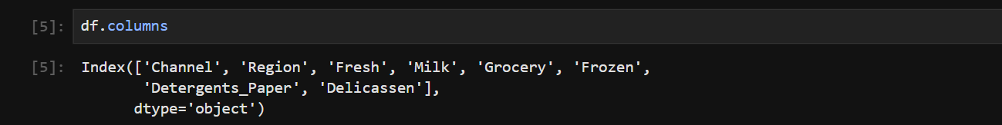this command prints all the feature columns present in our dataset.

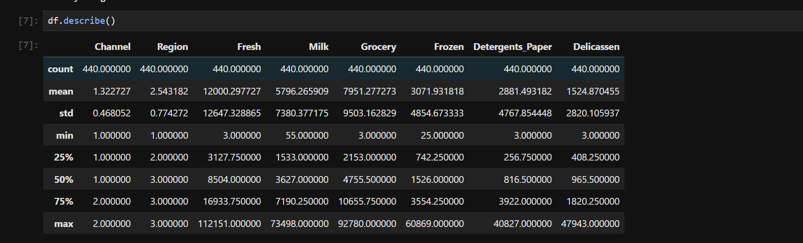this command prints all the calculation for our dataset values like mean, mode var, std needed for statistical calculations.

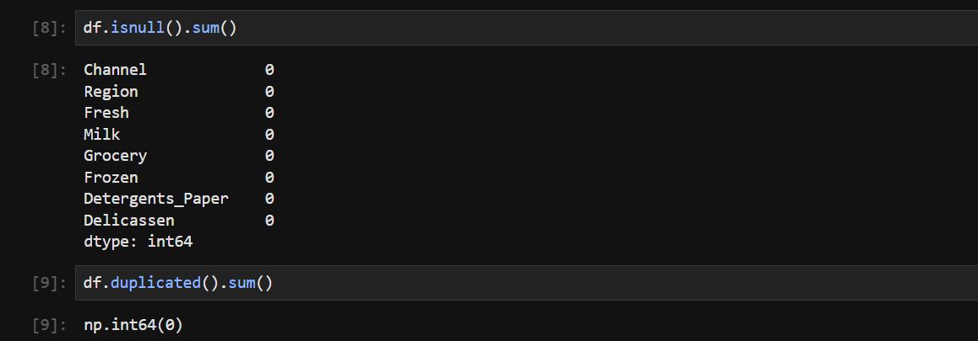this command prints all the null values present in eachcolumn of our dataset.

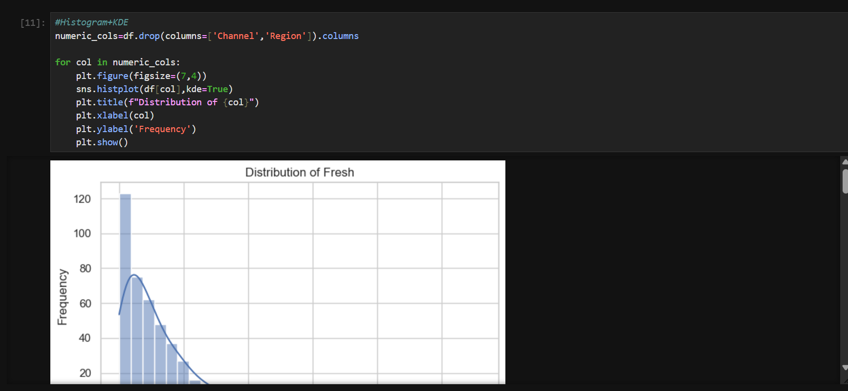
This command does all the visual representation for our univariate analysis like histogram, boxplot for outlier detection,

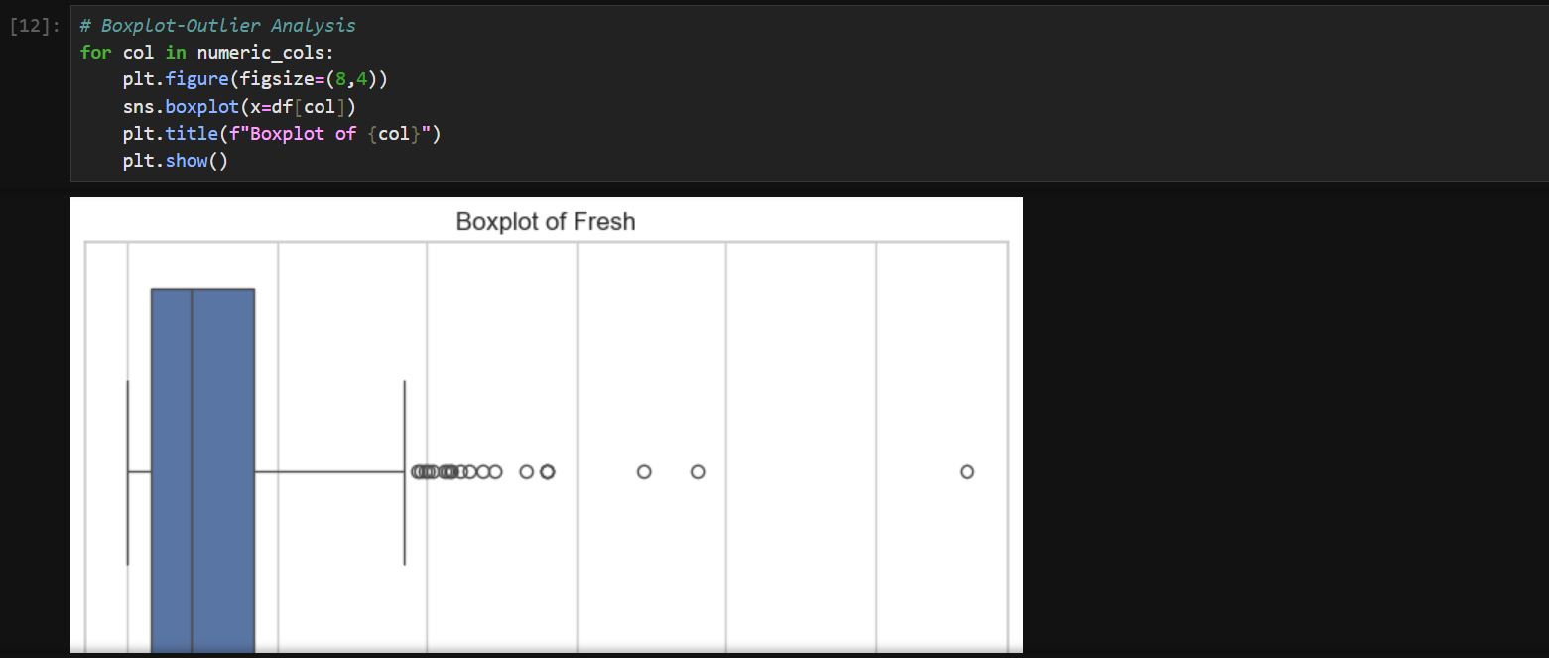
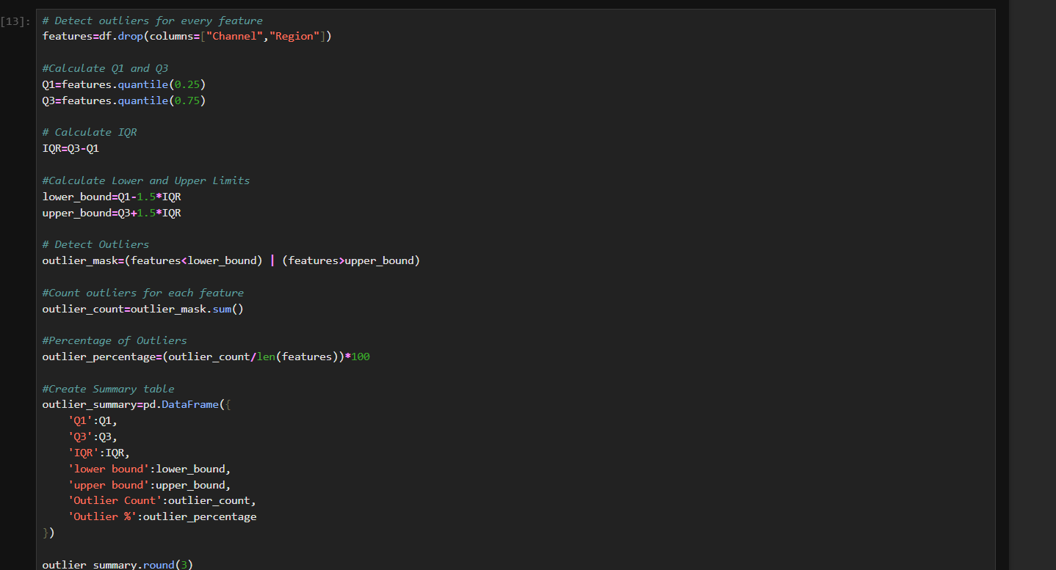
This command does the calculation for all the outlier present in our dataset, by using the iqr method.

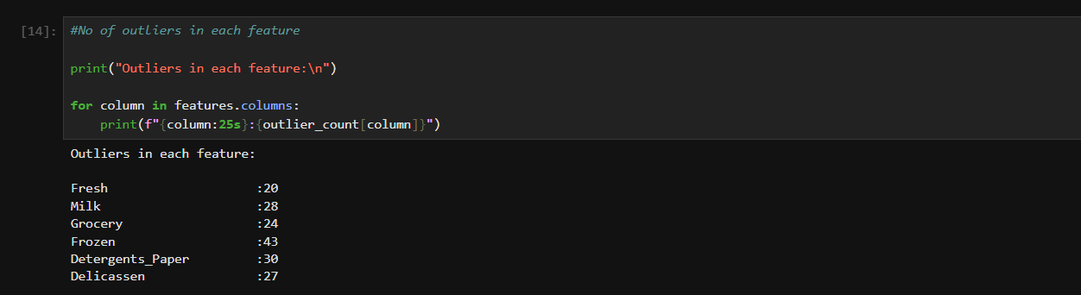this command prints the total outlier present in each column of our dataset.

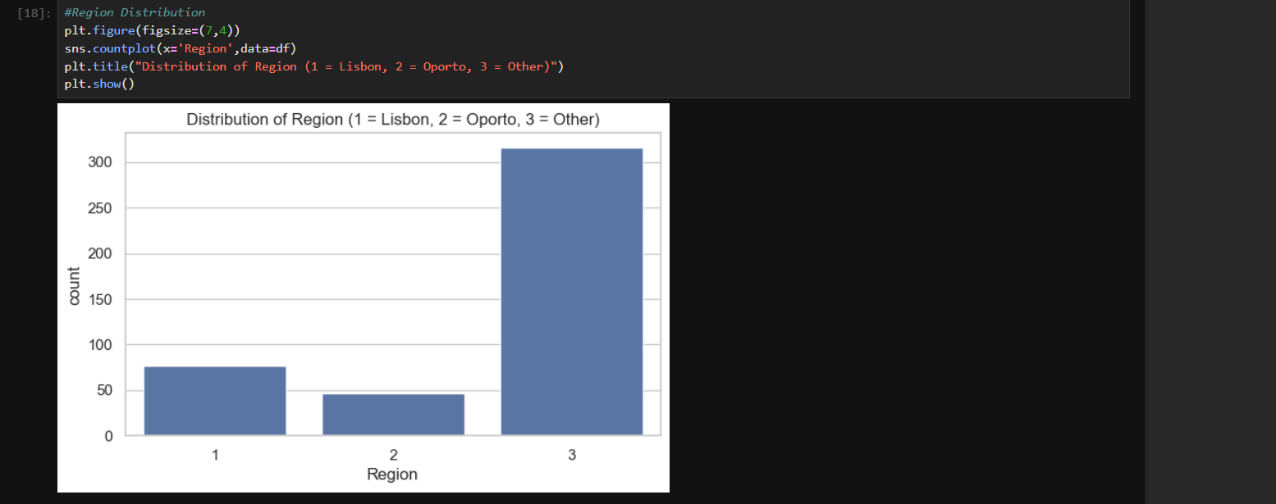
This command shows the distribution region wise of wholesale goods,

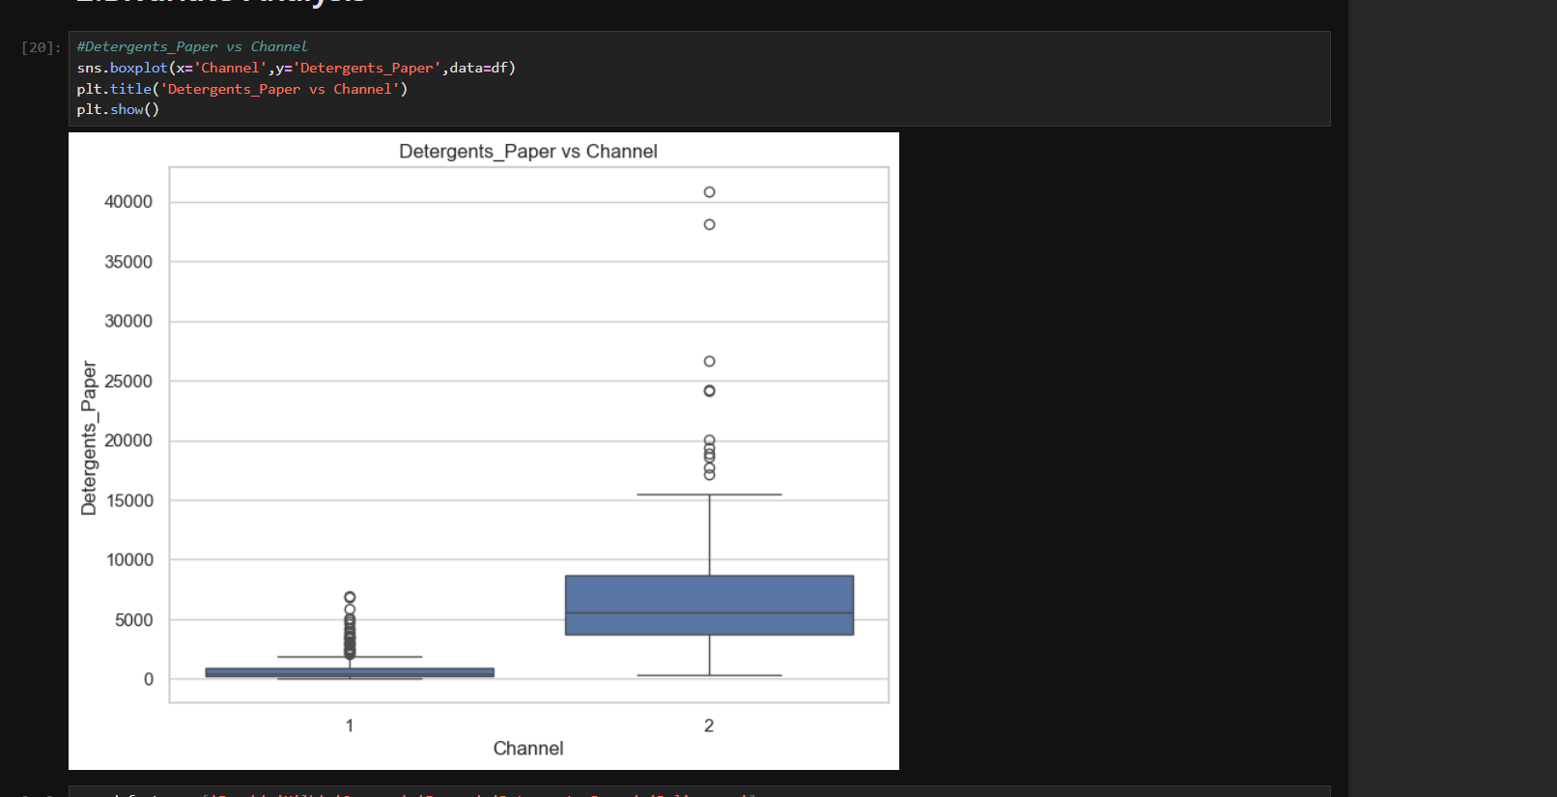
This command shows the bivariate analysis for out dataset.

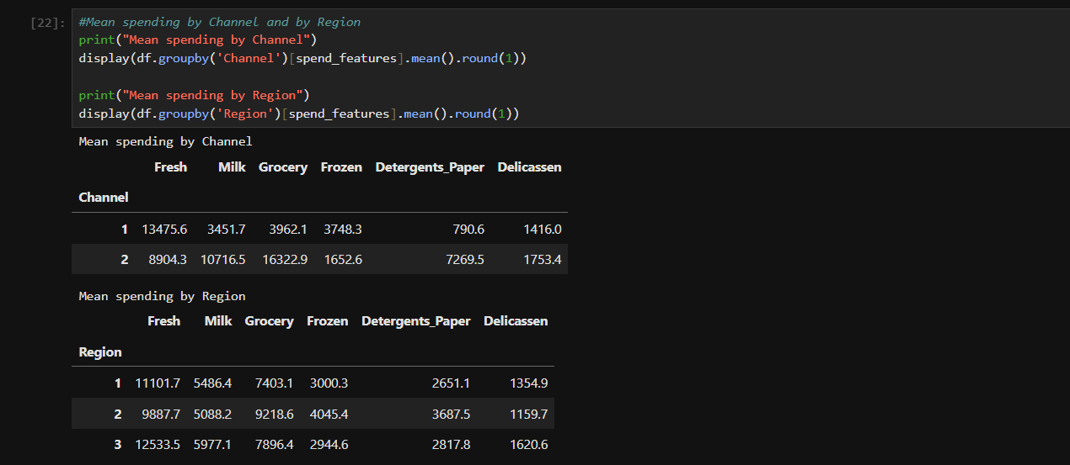
This command prints the mean spending by each channel and regionwise sales of wholesale goods.

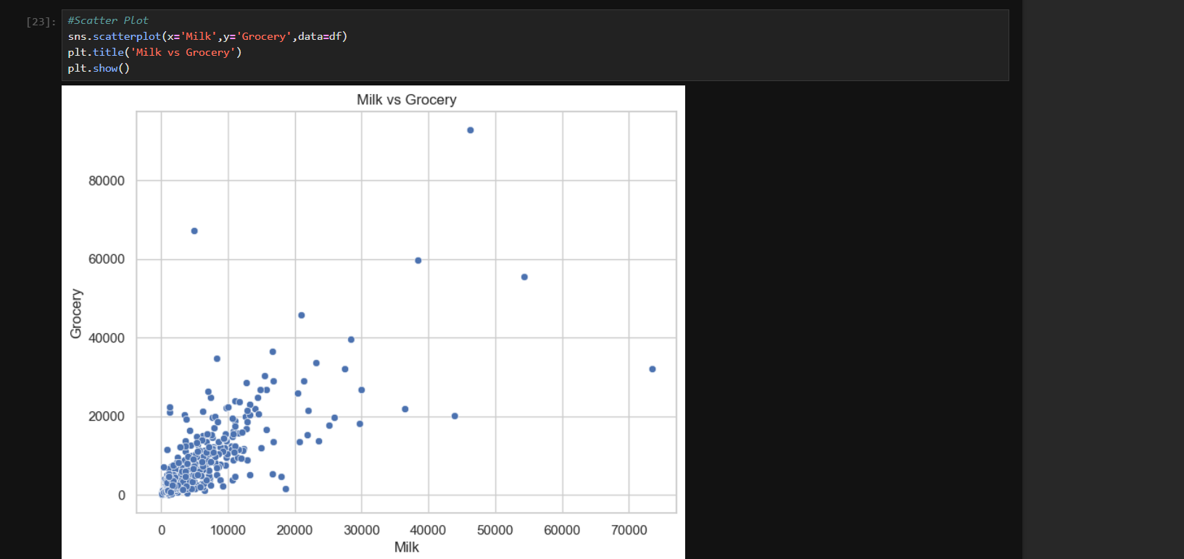this is visual represenation for sale of milk .

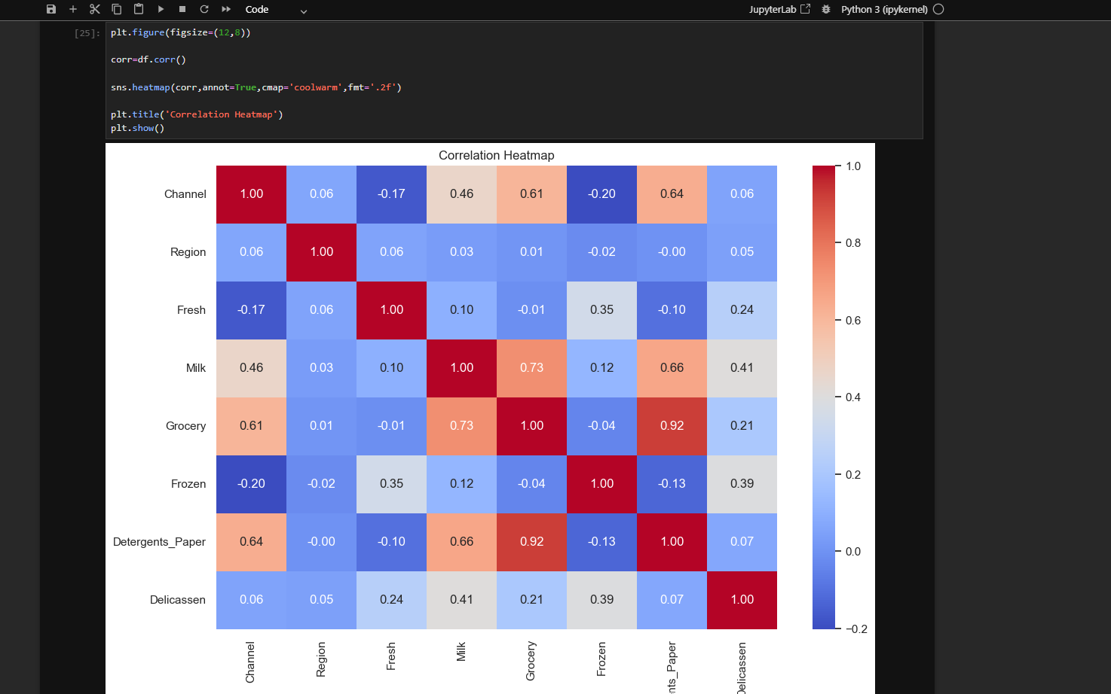this command prints the heatmap of our values and their correlation between all features in our dataset, dark color means max correlation and lighter shade means least correlation.

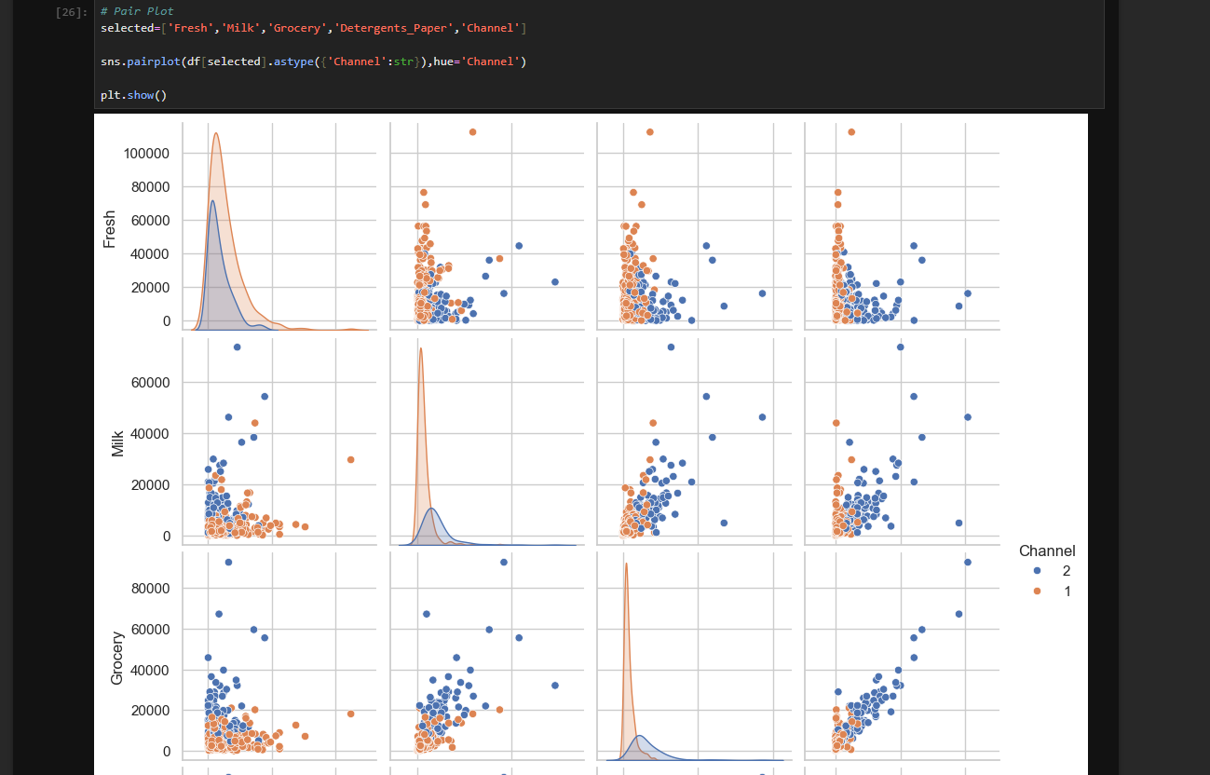this command also prints the pair plot of multiple feature columns in one go .
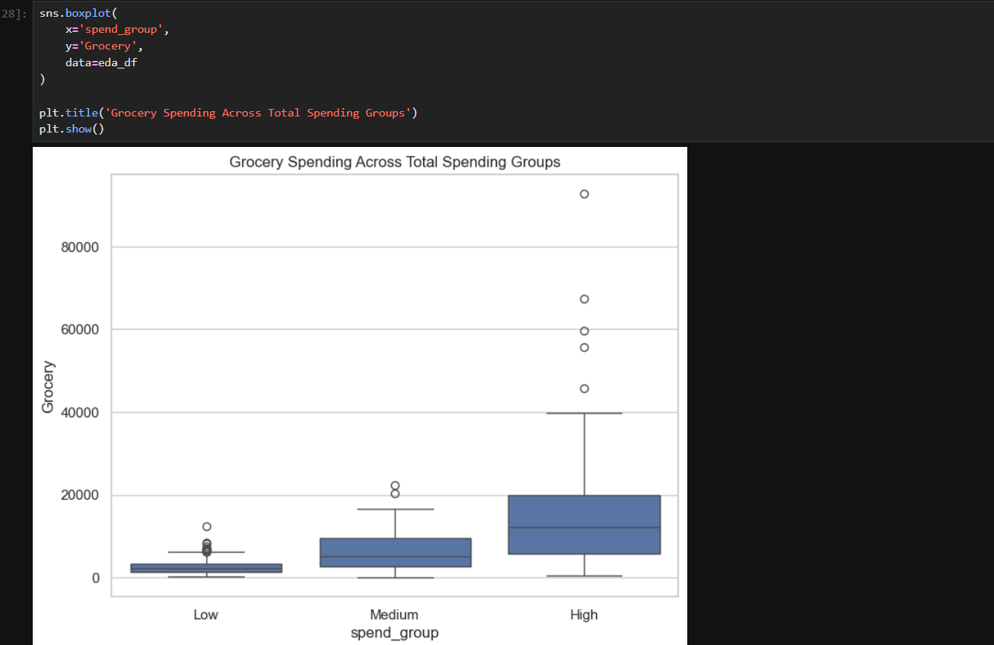this command prints a boxplot of spending in grocery range wise like low, medium or high based on their range of spending.

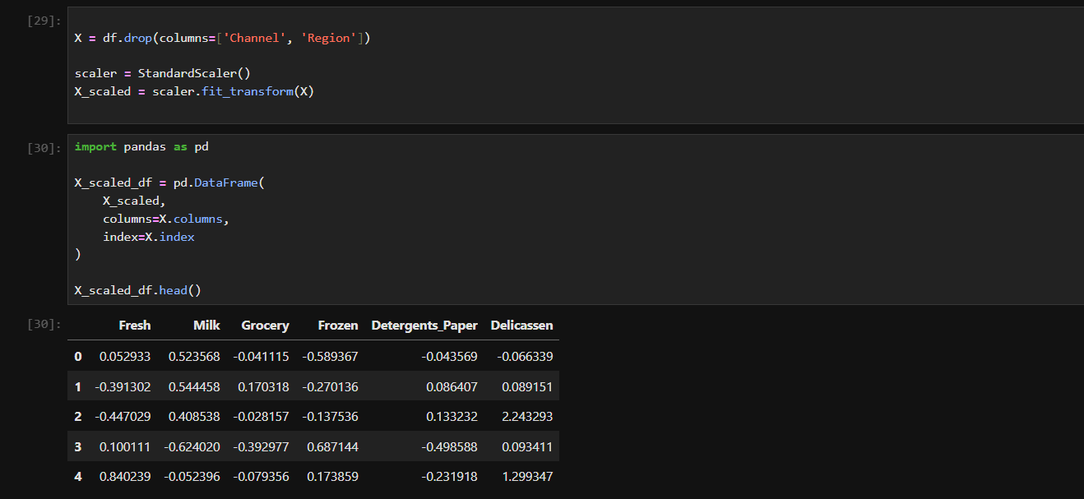this command does the standard scaling of out values so no large value can individually influence the prediction of ml model ,

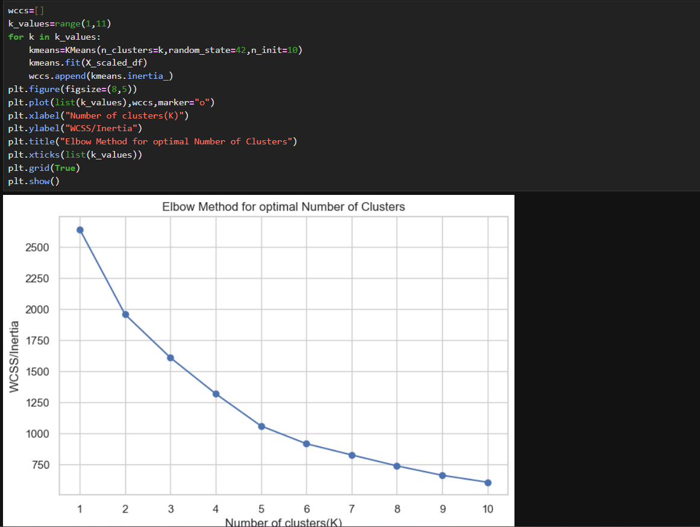this command prints elbow type graph for diff values of k and shows visual representation of it .

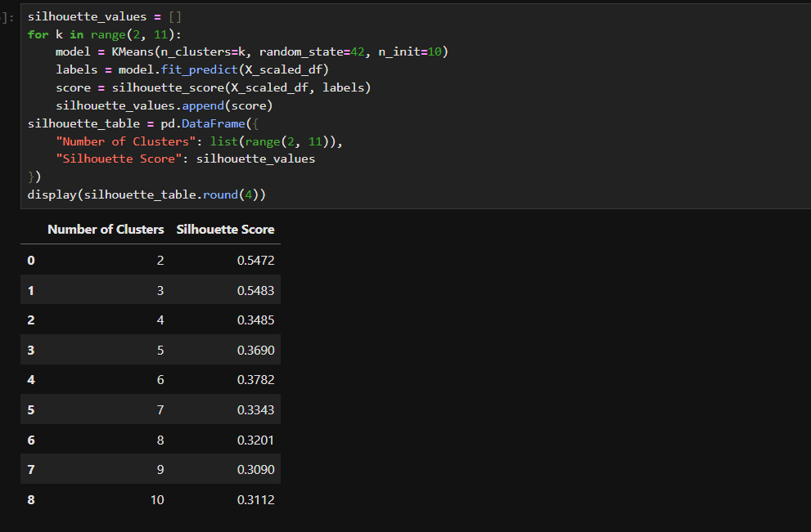this command prints the silloute score for each cluster in table format for more simple comparison.
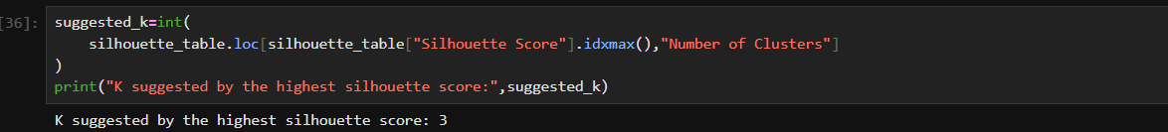
This command prints the best value of k based on silloute score obtained from above .

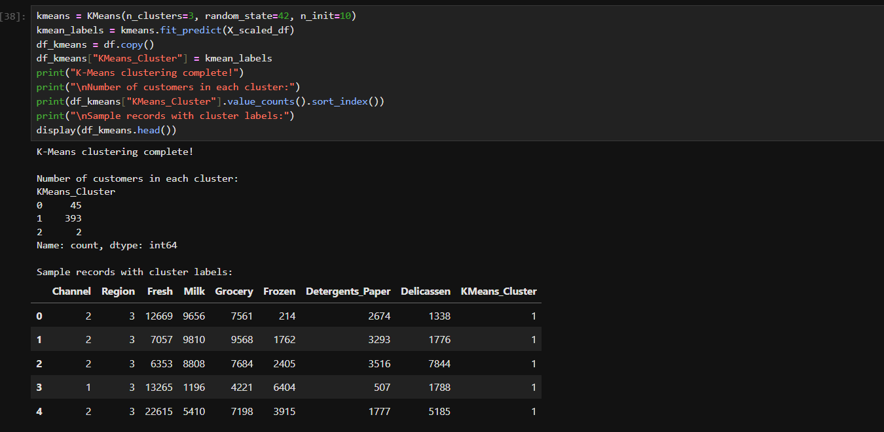
This command trains the model and prints random values of silloute for diff values of k and different cluster number .

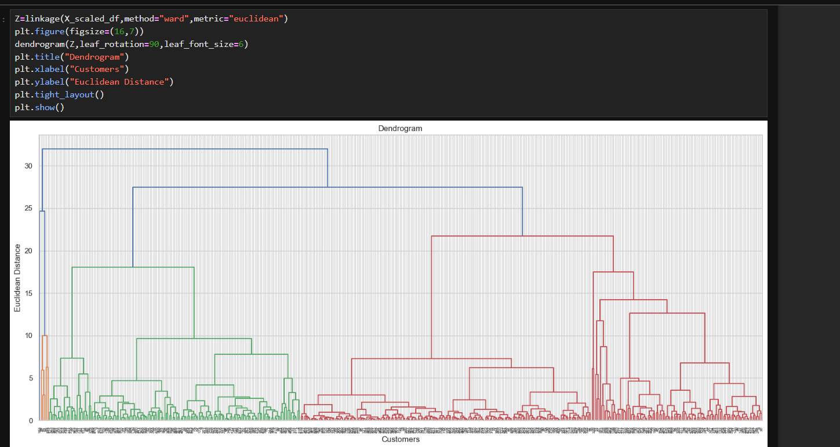this command prints the dendogram for out cluster formed.

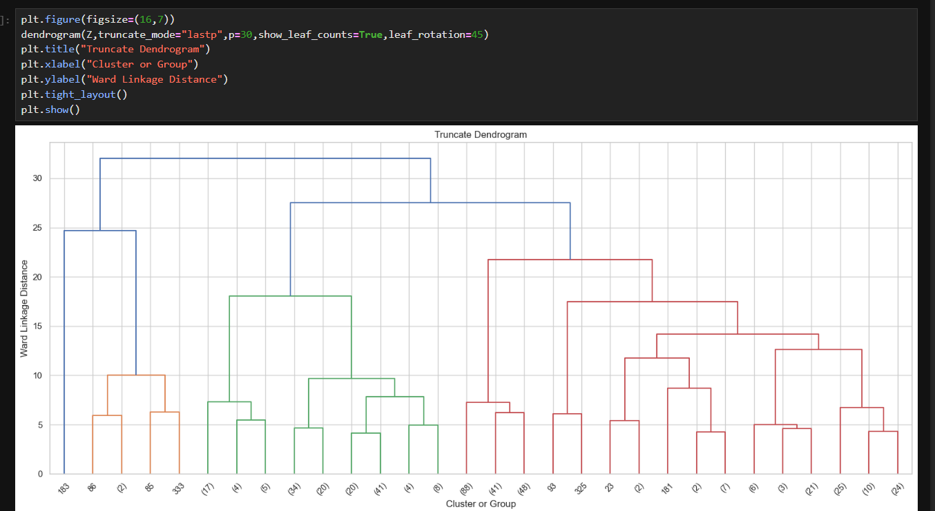this is dendogram but with a limit so its more visible and doesn’t overfits.

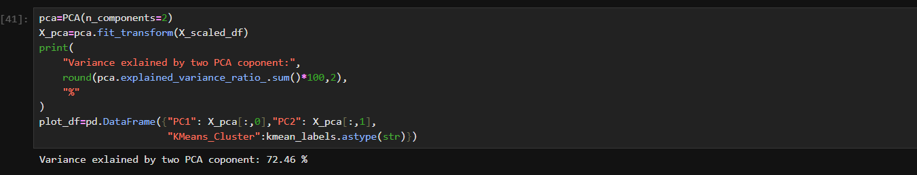 PCA squeezes the 6 features into 2 new columns (PC1, PC2) so we can plot in 2D, and they keep 72.46% of the information
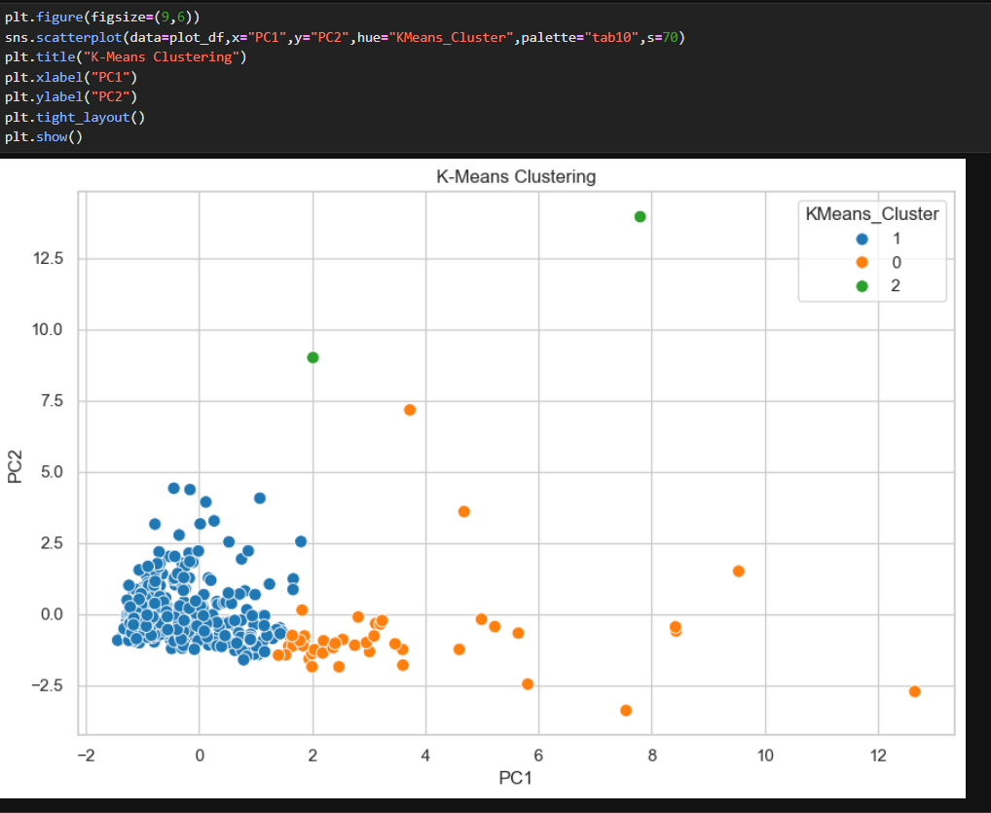
Cluster 1 is the big dense group, Cluster 0 is spread out, and Cluster 2 is just 2 far-away points.

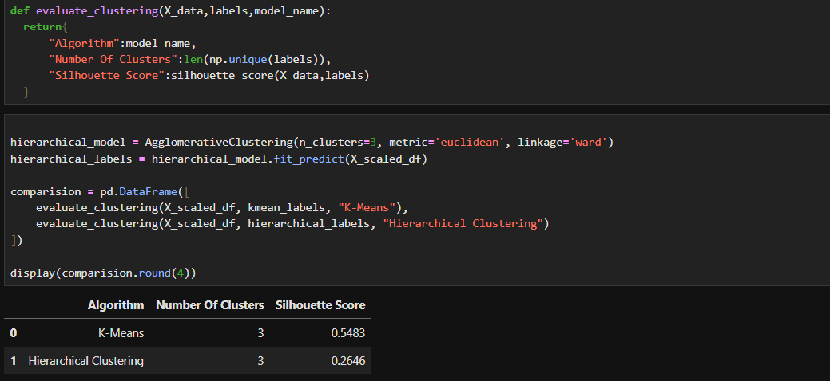
This command makes a function so code is recalled anytime and compared both algo on basis of clusters and silhouette score.

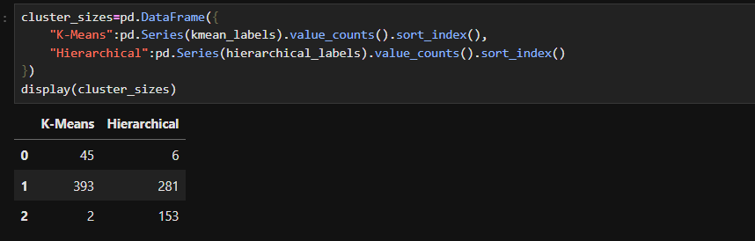
Counts how many customers each algorithm put in each cluster

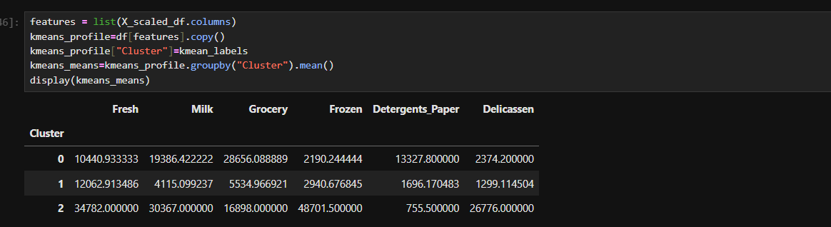
Adds the cluster label to the original (unscaled) spending data and finds the average spend of each cluster.

VIVA QUESTIONS
Q1. Why did we scale the data using StandardScaler before clustering?
Ans: Clustering uses distance. Fresh has huge numbers and would dominate the small ones, so scaling brings all columns to the same level.
Q2. What is the difference between the Elbow Method and the Silhouette Score?
Ans: Elbow Method plots inertia for different K and we pick the bend point. Silhouette Score tells how well separated the clusters are, higher is better. We got the best score at K = 3.
Q3. Why did we drop the Channel and Region columns before clustering?
Ans: They are just category codes (1, 2, 3), not spending amounts. So we used only the 6 spending columns for clustering.
Q4. What is a dendrogram?
Ans: It is a tree diagram that shows how customers get merged into clusters step by step. Taller lines mean the clusters are more different from each other.
Q5. Which algorithm performed better, K-Means or Hierarchical?
Ans: K-Means, because its silhouette score was 0.5483 and Hierarchical’s was 0.2646. But K-Means made one tiny cluster of just 2 outlier customers.

